Project Design Phase-II Technology Stack (Architecture & Stack)

|  |  |
| --- | --- |
| Date | 03 October 2022 |
| Team ID | PNT2022TMID05007 |
| Project Name | Project – Plasma Donor Application |
| Maximum Marks | 4 Marks |

Technical Architecture:

The Deliverable shall include the architectural diagram as below and the information as per the table1 & table 2

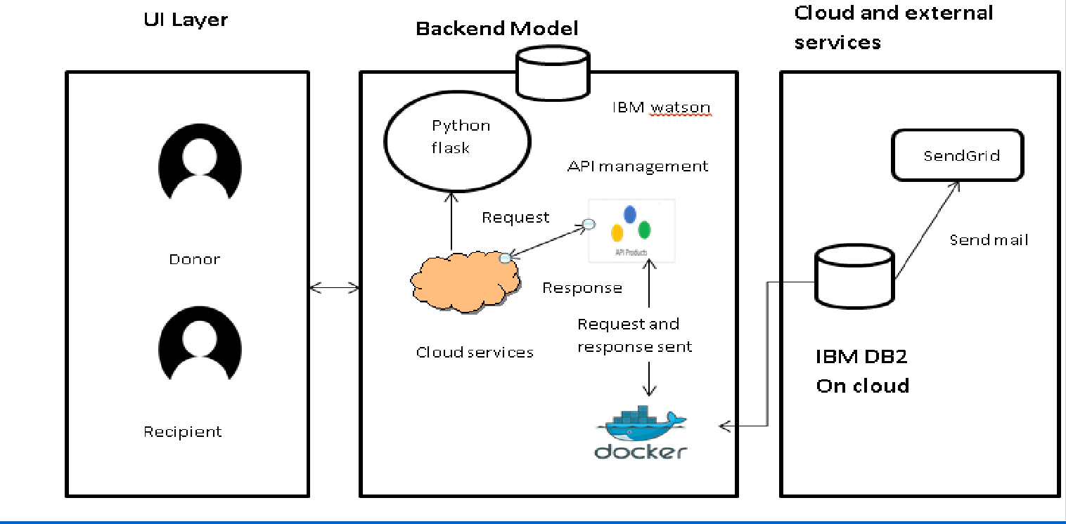

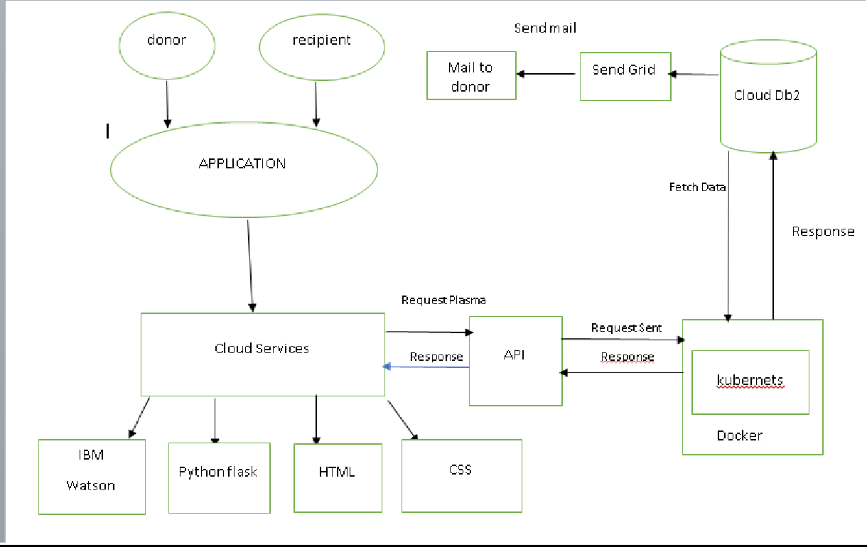

Guidelines:

1. Include all the processes (As an application logic / Technology Block)
2. Provide infrastructural demarcation (Local / Cloud)
3. Indicate external interfaces (third party API’s etc.)
4. Indicate Data Storage components / services
5. Indicate interface to machine learning models (if

applicable)

Table-1 : Components & Technologies:

|  |  |  |  |
| --- | --- | --- | --- |
| **S.No** | **Component** | **Description** | **Technology** |
| 1. | User Interface | The user register and login.  See the UI. | HTML, CSS, Python Flask |
| 2. | Data maintenance | Store , maintain ,retrieve the user’s details. | MYSQL |
| 3. | Chatbot | Clarify user queries. | IBM Watson service |
| 4. | Confirmation Email | Sending the confirmation email to users they have registered successfully. | SendGrid |
| 5. | Cloud Database | Cloud database to store plasma information and View Plasma information. | IBM DB2 |
| 6. | File Storage | File storage requirements | IBM Block Storage |
| 7. | Infrastructure (Server / Cloud) | To deploy the application on Local System | Kubernetes |

Table-2: Application Characteristics:

|  |  |  |  |
| --- | --- | --- | --- |
| **S.No** | **Characteristics** | **Description** | **Technology** |
| 1. | Open-Source Frameworks | Python Flask frameworks is used. | Python Flask |
| 2. | Security Implementations | Mandatory Control(MAC) and kubernetes is used. | SHA-256, Encryptions, IAM  Controls, OWASP etc. |
| 3. | Scalable Architecture | 3-Tier Architecture is used. | Web server-HTML,CSS Application Server- Python Flask Database Server-IBM DB2 |
| 4. | Availability | Using Load Balancer to distribute network traffic across Servers. | IBM Load Balancer |
| 5. | Performance | User Friendly UI.  Request and Response is faster. | IBM Content Delivery Network |

References:

<https://c4model.com/>

<https://developer.ibm.com/patterns/online-order-processing-system-during-pandemic/> <https://www.ibm.com/cloud/architecture>

<https://aws.amazon.com/architecture>

<https://medium.com/the-internal-startup/how-to-draw-useful-technical-architecture-diagrams-2d20c9fda90d>